**Electromyogram Signal Analysis Using MATLAB**

By

Elavarthi Sruthi 20BEC1028

Kola Sai Kishore 20BEC1224

A project report submitted to

**Dr. A. ANNIS FATHIMA**

**SCHOOL OF ELECTRONICS ENGINEERING**

In partial fulfilment of the requirements for the course of

**ECE2006 – Digital Signal Processing**

In

**B.Tech. ELECTRONICS AND COMMUNICATION ENGINEERING**



**Vellore Institute of Technology, Chennai**

**Vandalur-Kelambakkam Road, Chennai – 600127**

**April 2022**

**BONAFIDE CERTIFICATE**

Certified that this project report entitled “Electromyogram Signal Analysis Using

MATLAB**”** is a bonafide work of Elavarthi Sruthi(20BEC1028), Kola Sai Kishore(20BEC1224) who carried out the Project work under my supervision and guidance.

**Dr .ANNIS FATHIMA**

Associate Professor

School of Electronics Engineering (SENSE),

VIT University, Chennai

Chennai-600127.

**ABSTRACT**

* Electromyography (EMG) signals can be used for clinical/biomedical applications, Evolvable Hardware Chip (EHW) development, and modern human computer interaction. EMG signals acquired from muscles require advanced methods for detection, decomposition, processing, and classification.
* To illustrate the various methodologies and algorithms for EMG signal analysis to provide efficient and effective ways of understanding the signal and its nature. We further point up some of the hardware implementations using EMG focusing on applications related to prosthetic hand control, grasp recognition, and human computer interaction.
* Electromyography (EMG) is an electrodiagnostic medicine technique for evaluating and recording the electrical activity produced by skeletal muscles. EMG is performed using an instrument called an electromyograph to produce a record called an electromyogram.
* Electromyography is a method to evaluate levels of muscle activity. When a muscle contracts, an action potential is generated and this circulates along the muscular fibres. In electromyography, electrodes are connected to the skin and the electrical activity of muscles is measured and graph is plotted.
* Neuropathy is a medical condition in which individuals experience numbness in their limbs and Myopathy is a neuromuscular disorder in which the primary symptom is muscle weakness.
* This can cause gait impairment, such as difficulty in walking, climbing stairs or maintaining balance. In order to find a means to correct an individual’s gait, a precise observation of the variation is needed.
* The surface EMG signals picked up during the muscular activity are interfaced with a system. The EMG signals from individual suffering from Neuropathy healthy and Myopathic individual so obtained, are processed and analysed using signal processing techniques.

This project includes the analysis of EMG signals of Healthy, Neuropathic and Myopathic Individuals using MATLAB. The prospective use of this study is in developing the prosthetic device for the people With Neuropathic disability and myopathic disorder.

**ACKNOWLEDGEMENT**

We wish to express our sincere thanks and deep sense of gratitude to our project guide, **Dr. Annis Fathima,** Professor, School of Electronics Engineering, for her consistent encouragement and valuable guidance offered to us in a pleasant manner throughout the course of the project work.

We are extremely grateful to **Dr. Susan Elias,** Dean of the School of Electronics Engineering, VIT Chennai, for extending the facilities of the School towards our project and for her unstinting support.

We express our thanks to our Programme Chair **Dr. Mohanaprasad K** for their support throughout the course of this project.

We also take this opportunity to thank all the faculty of the School for their support and their wisdom imparted to us throughout the course.

We thank our parents, family, and friends for bearing with us throughout the course of our project and for the opportunity they provided us in undergoing this course in such a prestigious institution.

**Team members**

Elavarthi Sruthi 20BEC1028

Kola Sai Kishore 20BEC1224

**TABLE OF CONTENTS**

|  |  |  |  |
| --- | --- | --- | --- |
| **SERIAL NO.** |  | **NAME** | **PAGE NO.** |
|  |  | ABSTRACT | 3 |
|  |  | ACKNOWLEDGEMENT | 4 |
| 1 |  | INTRODUCTION | 6 |
|  | 1.1 | OBJECTIVES AND GOALS | 6 |
| 2 |  | THEORY | 6 |
| 3 |  | Result and Analysis | 10 |
| 4 |  | CONCLUSION& OBSERVATION | 18 |
| 5 |  | REFFERENCES | 21 |
| 6 |  | APPENDIX- code | 22 |

1. **INTRODUCTION**

**1.1 OBJECTIVES and GOALS**

During the needle EMG, the neurologist will assess whether there is any spontaneous electrical activity when the muscle is at rest — activity that isn't present in healthy muscle tissue - and the degree of activity when you slightly contract the muscle.

Ny this we need to be able to discover whether the patient is heathy or disordered with myopathy or neuropathy

1. **THEORY**

**Block Diagram**

First and foremost, a block diagram must be designed to be the basic reference. Based on below figure, this is a general block diagram of this experiment. The system was received three different EMG signals coming from three different patients. Then, the system was identified the signal belong to which patient

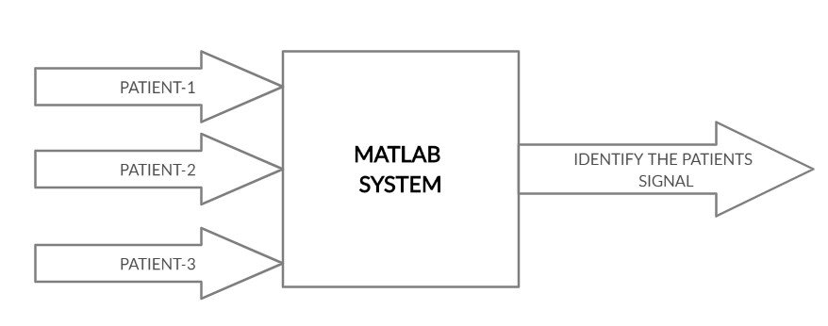

**Algorithm**

The project involves an analysis of EMG signals of a healthy individual, a myopathic person and neuropathic person. The data were recorded at 50 KHz and then down-sampled to 4 KHz

During the recording process two analog filters were used: a 20 Hz high-pass filter and a 5K Hz low-pass filter. A comparative study is done based on the analysis of various factors which are obtained using MATLAB and observed graphically.

The detailed procedure is given below as:

**STEP 1:** EMG signal of healthy, myopathic and neuropathic individuals are obtained in txt format and loaded into the MATLAB environment.

**STEP 2:** The length of the data per second and its size is found and the sampling rate is calculated. The EMG signals are plotted and the graph is obtained.

**STEP 3:** To obtain the signal's power within the given frequency range the power spectrum is plotted.

**STEP 4:** Next, the RMS (Root Mean Square) value is calculated. To capture the EMG envelope, the root mean square (RMS) value of the signal is computed within a window which "slides

**STEP 5:** The rectification step is essential for getting the shape or "envelope" of the EMG signal. Average rectified value is calculated. If one first rectifies, the negative swings turn into across the signal. The RMS value of the signal that is in the window is plotted at the centre of the window, to avoid time shifts in the envelope relative to the signal positive swings

**STEP 6:** Remove any DC offset of the given signal. Rectified EMG signal is plotted.

**STEP 7:** Time Frequency Analysis: We need to calculate the frequency content of the signal for short, perhaps overlapping, time segments. This is done by Fast Fourier Transform (FFT).

The **Root Mean Square (RMS**) value has been used to quantify the electric signal because it reflects the physiological activity during contraction. The RMS value of the EMG signal of the mentioned muscles was measured by the given formula.

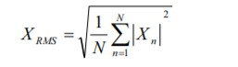

The **average rectified value (ARV)** of the EMG signal is the average of its absolute value. The rectified average is then the mean of the integral of the function's absolute value.

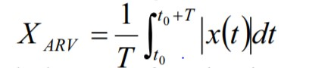

**Locate Muscle Activation:**

When performing gait analysis, exercise physiology, startle response, or other research, identification of periods where the muscle is active can allow for correlation of external factors to muscle activity. Locate Muscle Activation attempts to identify various periods of muscle activity using statistical methods. The transformation requires a raw, unfiltered surface EMG channel. It is important that the muscle being examined is relaxed for the first

0.25 seconds of the recording to provide an estimate of the ‚background noise‚ during areas of muscle relaxation. This quarter-second period is used to estimate baseline parameters that affect the entire process. EMG Frequency & Power Analysis Several frequency domain techniques may be used for data reduction of EMG signals.

**The EMG Frequency & Power Analysis:**

several measures derived from the power spectrum of an EMG signal. The EMG signal is split up into a fixed number of time periods; within each window, the power spectrum is computed using the Power Spectral Density transformation. For each time period, the following measures are extracted: Median Frequency, Mean Frequency, Peak Frequency, Mean Power, and Total Power

1. **RESULT AND ANALYSIS**

**Dataset**

Datasets have been taken from taken from internet.

**Tools used**

Matlab software

**Code**

clc;

close all; clear all;

EMGSIG = load('emg_healthy.txt'); %replace the txt file accordingly t = EMGSIG(:, 1); y1 = EMGSIG(:, 2); N = length(y1); ls = size(y1); f = 1/N; fs = 3000; T = 1/fs; t1 = (0 : N-1) *T; Nyquist = fs/2; figure; subplot (3,1,1); plot(t,y1);

title ('EMG signal of single muscle of healthy patient');

xlabel ('time (sec)'); ylabel ('Amplitute (V)'); grid on; Y= abs(fft(y1)); Y(1) = []; power = abs(Y(1:N/2)).^2; nyquist = 1/(2*0.001); freq = (1:N/2)/(N/2)*nyquist; subplot(212), plot(freq,power), grid on xlabel('Sample number (in Frequency)') ylabel('Power spectrumen'); title({'Single-sided Power spectrum' ... ' (Frequency in shown on a log scale)'}); axis tight rms_y1 = sqrt(mean(y1.^2)); msgbox(strcat('RMS of EMG signal is = ',mat2str(rms_y1),'')); arv_y1 = abs(mean(y1));

msgbox(strcat('ARV of EMG signal is = ',mat2str(arv_y1),'')); y2 = detrend(y1); figure; rec_y = abs(y2); plot (rec_y);

xlabel('Sample number (in Frequency)') ylabel('Rectified EMG signal');

title({'Rectified EMG signal (Frequency in shown on a log scale)'}); figure; xdft = fft(y1); xdft = xdft(1:N/2+1); psdx = (1/(fs*N)) * abs(xdft).^2; psdx(2:end-1) = 2*psdx(2:end-1); freq = 0:fs/length(y1):fs/2;

plot(freq,10*log10(psdx)) grid on title(' Power spectrum FFT') xlabel('Frequency (Hz)') ylabel('Power/Frequency (dB/Hz)')

NFFT = 2 ^ nextpow2(N); Y = fft(y1, NFFT) / N; f = (fs / 2 * linspace(0, 1, NFFT / 2+1)); amp = ( 2 * abs(Y(1: NFFT / 2+1)));

figure; plot(f,amp);

title('plot single-sided amplitude spectrume of the EMG signal') xlabel('frequency (Hz)')

ylabel('|y(f)|')

**Result**

**EMG signal analysis of Healthy person:**

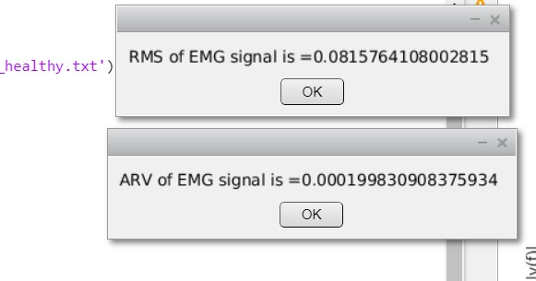

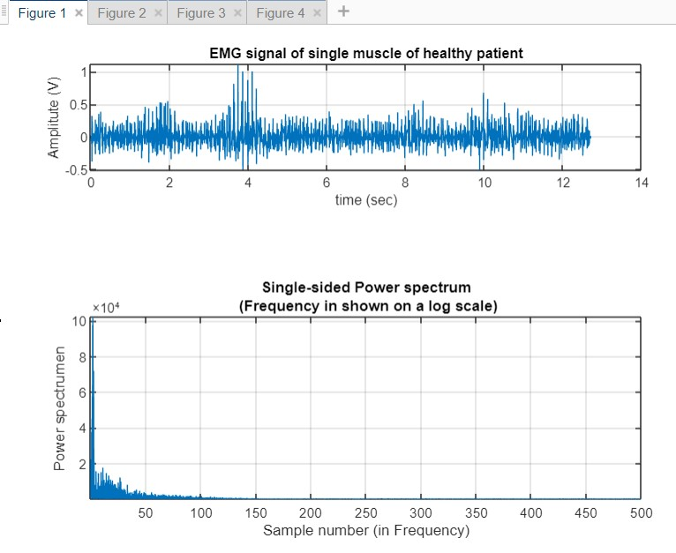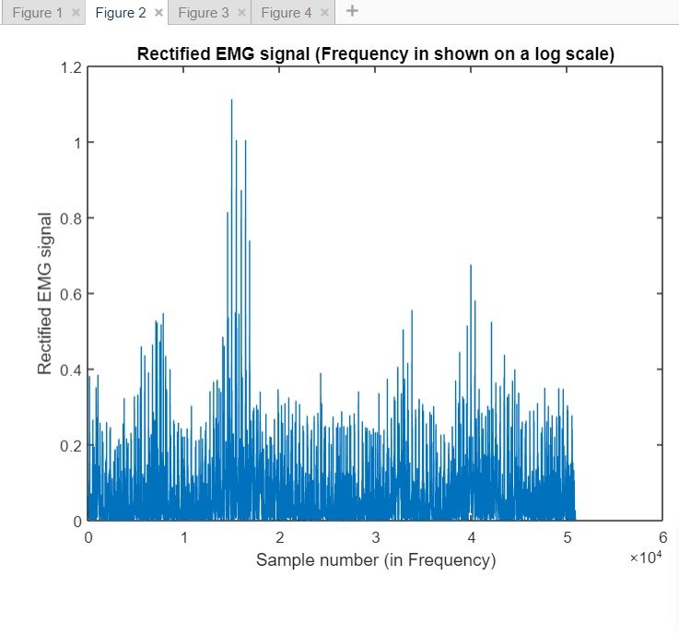

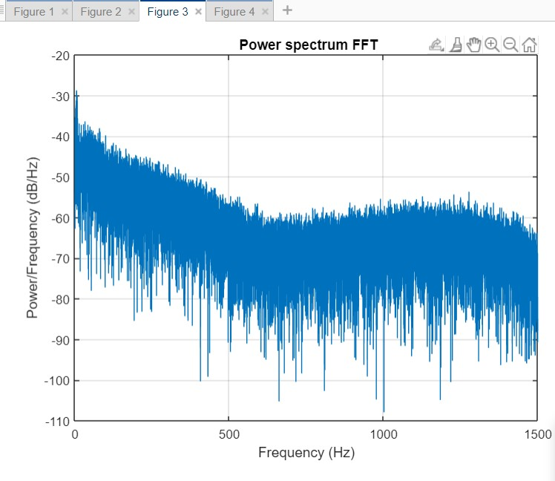

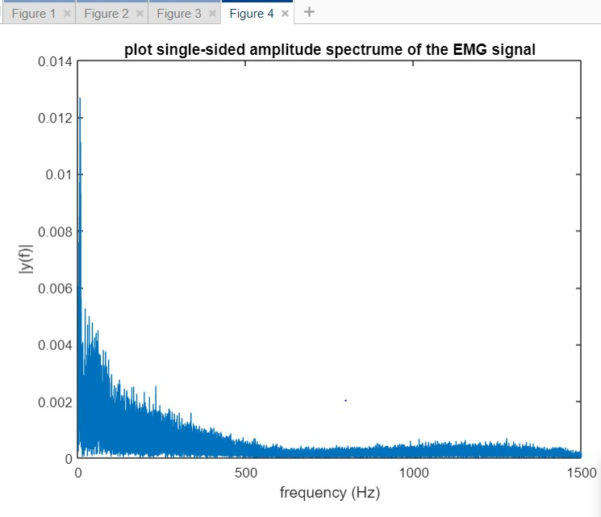

**EMG signal analysis of Myopathic person:**

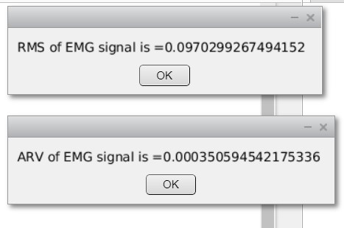

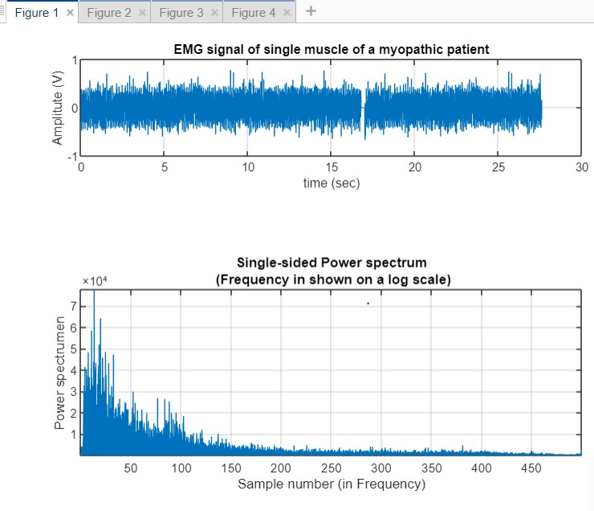

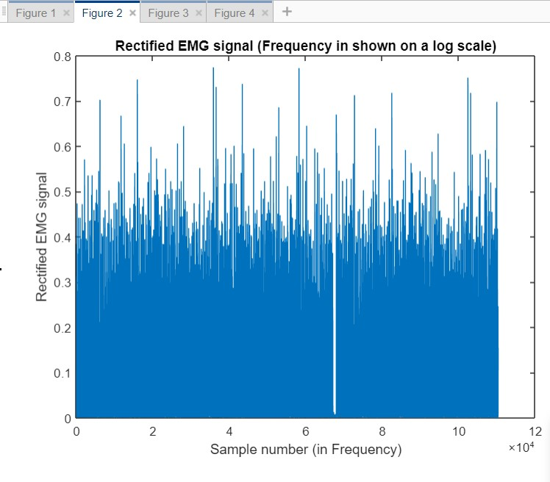

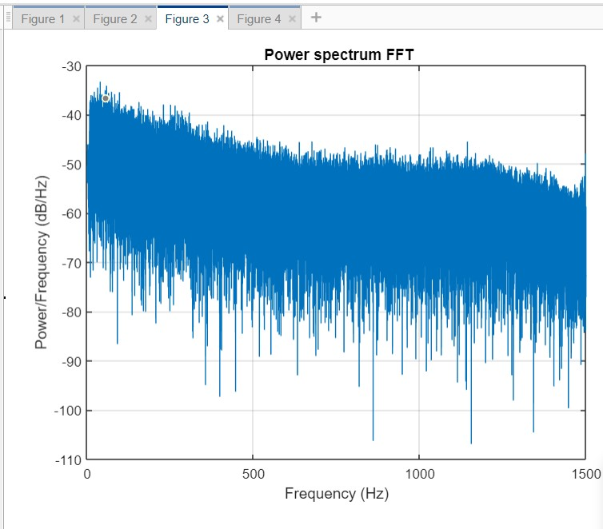

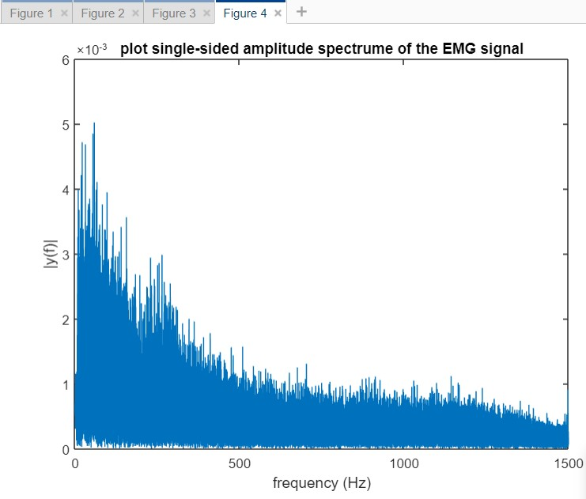

**EMG signal analysis of Neuropathic person:**

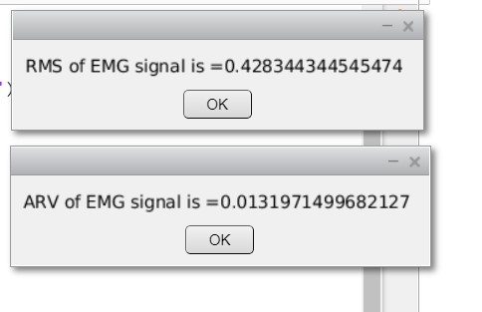

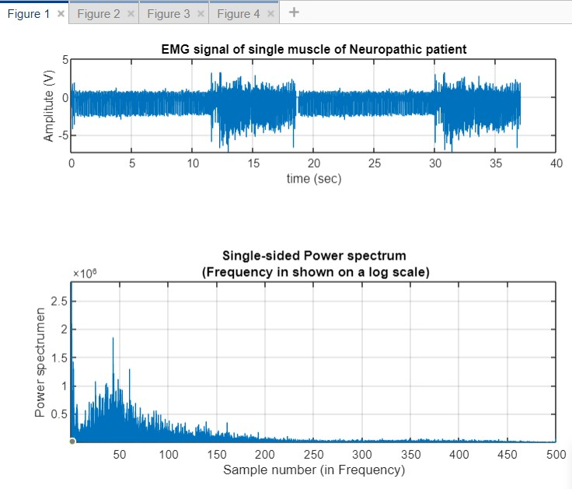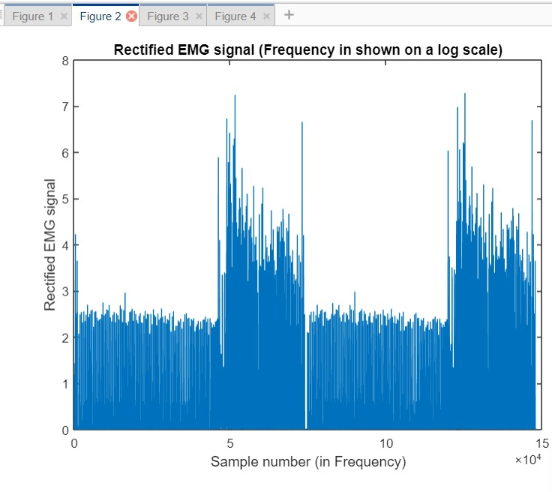

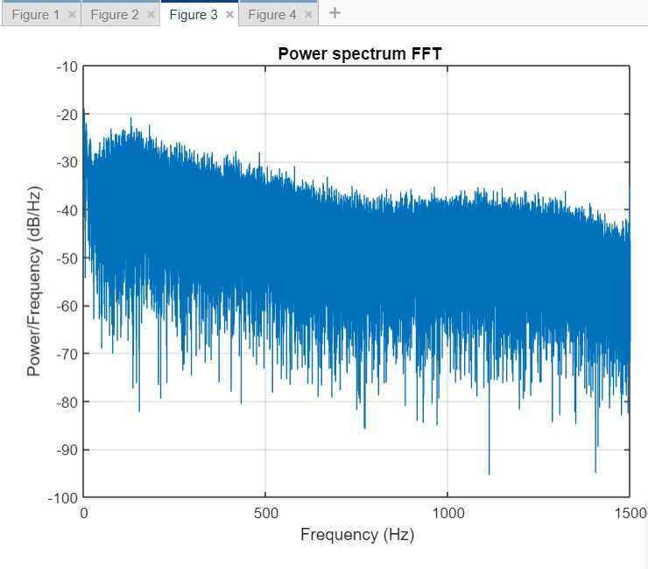

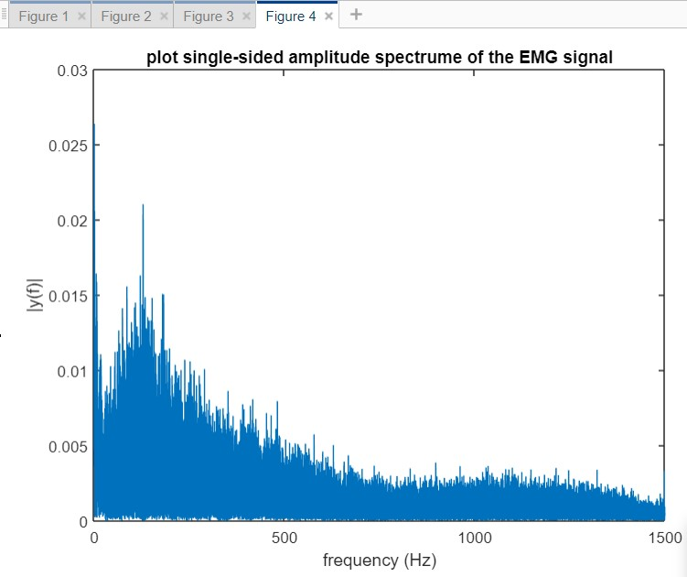

1. **CONCLUSION**

EMG signal carries valuable information regarding the nerve system. Signal conditioning and signal processing are very critical to obtain a reliable result from surface EMG. The noisy nature of EMG signals is still harness for enlarging the application of EMG for various clinical studies. Hence, still there is an eminent request for novel techniques that address improving the quality of measured EMG signals. Techniques for EMG signal such as:

Filtering Decomposition process Modelling were discussed.

**OBSERVATIONS:**

The RMS and ARV values are tabulated as following:

|  |  |  |  |
| --- | --- | --- | --- |
| **parameter** |  | **subject** |  |
| **healthy** | **myopathic** | **neuropathic** |
| **Root mean square** | **0.0815764108** | **0.0970299267** | **0.42834454** |
| **Average rectified value** | **0.00019983090** | **0.00035059** | **0.01319714** |

The RMS and ARV values are plotted as following:

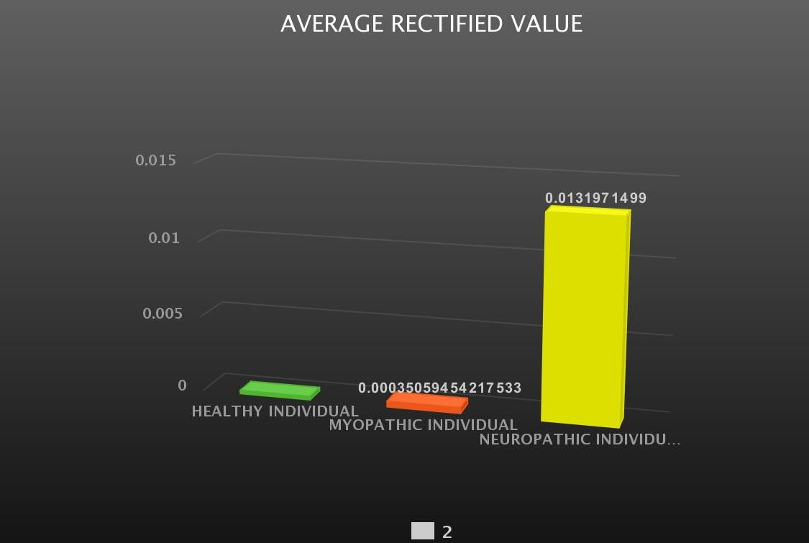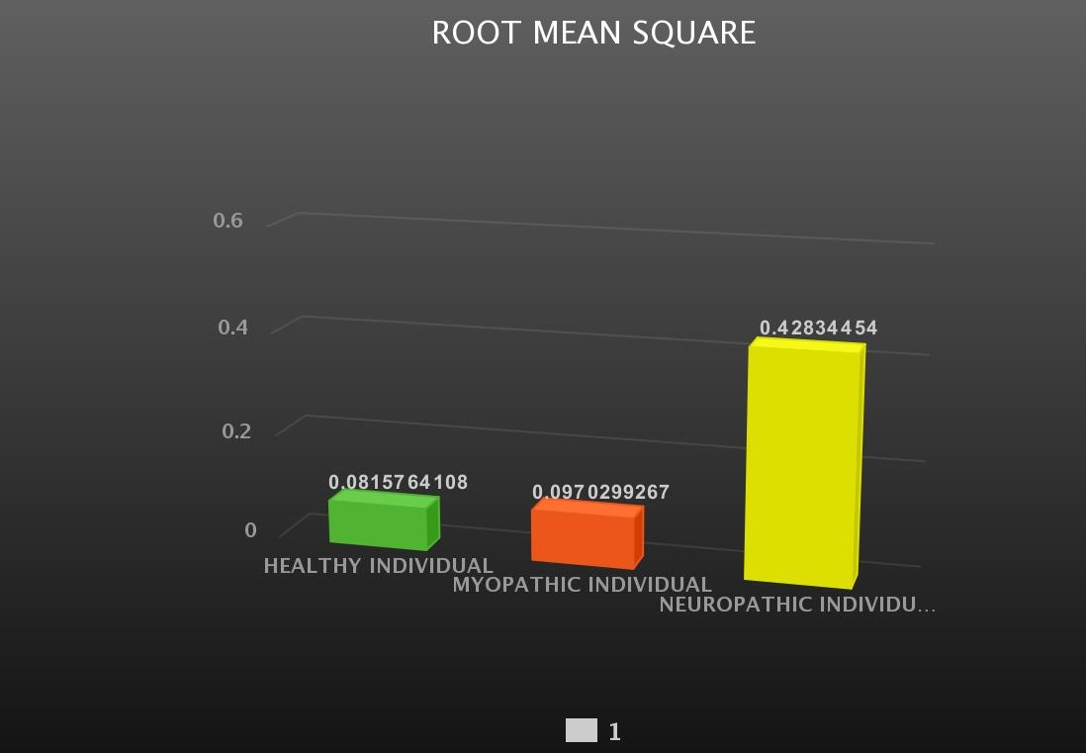

* The values of average rectified value (ARV) and root mean square (RMS) of EMG signals of healthy, Myopathic and Neuropathic individuals obtained shows a difference between the EMG signals of the three individuals.

* The RMS value for healthy patient is 0.08157, RMS value for Myopathic patient is 0.0970299 and RMS value for the neuropathic individual is 0.428344.

* The ARV for healthy person is 0.0001998, the ARV for Myopathic patient is

0.0003505 and the ARV for neuropathic individual is 0.01319.

* The ARV and RMS values for healthy individual and Myopathic individual are lesser than that of the Neuropathic individual as per the bar graphs plotted.

Observations similar to RMS and ARV values have been made with respect to the power spectrum and time-frequency analyzed EMG signals, when a comparison is made between the plots of power spectrum and time-frequency analysis of healthy, myopathic and Neuropathic individuals. The peaks of power spectrum and time-frequency plots of Neuropathic patient are higher than that of the healthy person and myopathic patient. These can be seen in the results section above.

**Future scope**

Future applications of SEMG in Ergonomics SEMG in Ergonomics:

possibilities and limitations, Rolf Westgaard (Norway) Muscular stabilization of the spine: a functional explanation for changed patterns of trunk muscle activity in low-back pain patients? Jaap van Dieen (the Netherlands) EMG techniques can be used to measure spinal loading during assymetric lifting tasks, Trish Dolan, (United Kingdom) SEMG time normalisation in occupational settings, Pascal Madeleine (Denmark) Load pattern in the upper trapezius muscle in dentalhygienists with or without neck / shoulder disorders, Dirk Jonker (Sweden) Future applications of SEMG in ambulatory back load estimation, Chris Baten (Enschede, the Netherlands)

Future applications of SEMG in Neuro(physio)logy:

The use of Surface EMG in the assessment of disorders of nerve and muscle, Machiel Zwarts (the Netherlands) Changes in metabolism and electrophysiology during sustained contraction, Astrid Trachterna (Germany) High density SEMG during transient paresis in becker’s myutonia, Gea Drost (the Netherlands) Single motor unit discharge patterns recorded with multi-channel SEMG, Bert Kleine (the Netherlands) A SEMG-based system for clinical applications using Laplacian electrodes, Jean Yves Hogrel (France)

**5. REFFERENCES**

* **<https://www.ncbi.nlm.nih.gov/pmc/articles/PMC2989313/>**

* [**https://www.ncbi.nlm.nih.gov/core/lw/2.0/html/tileshop_p mc/tileshop_pmc_inline.html?title=Click%20on%20imag**](https://www.ncbi.nlm.nih.gov/core/lw/2.0/html/tileshop_pmc/tileshop_pmc_inline.html?title=Click%20on%20image%20to%20zoom&p=PMC3&id=2989313_1475-925X-9-72-2.jpg)

[**e%20to%20zoom&p=PMC3&id=2989313_1475-925X-9-**](https://www.ncbi.nlm.nih.gov/core/lw/2.0/html/tileshop_pmc/tileshop_pmc_inline.html?title=Click%20on%20image%20to%20zoom&p=PMC3&id=2989313_1475-925X-9-72-2.jpg)

[**72-2.jpg**](https://www.ncbi.nlm.nih.gov/core/lw/2.0/html/tileshop_pmc/tileshop_pmc_inline.html?title=Click%20on%20image%20to%20zoom&p=PMC3&id=2989313_1475-925X-9-72-2.jpg)

* [**https://biologicalproceduresonline.biomedcentral.com/tra ck/pdf/10.%201251/bpo115**](https://biologicalproceduresonline.biomedcentral.com/track/pdf/10.%201251/bpo115)

* [**https://ieeexplore.ieee.org/abstract/document/7319070**](https://ieeexplore.ieee.org/abstract/document/7319070)

* [**https://www.biopac.com/application/emgelectromyograp hy/advanced-feature/automated-emg-analysis/**](https://www.biopac.com/application/emgelectromyography/advanced-feature/automated-emg-analysis/)

* [**https://iopscience.iop.org/article/10.1088/1757-**](https://iopscience.iop.org/article/10.1088/1757-899X/225/1/012128)

[**899X/225/1/012128**](https://iopscience.iop.org/article/10.1088/1757-899X/225/1/012128)

* [**https://link.springer.com/article/10.1251/bpo115**](https://link.springer.com/article/10.1251/bpo115)

* [**https://ieeexplore.ieee.org/abstract/document/7538330**](https://ieeexplore.ieee.org/abstract/document/7538330)

* [**https://ieeexplore.ieee.org/abstract/document/8350893**](https://ieeexplore.ieee.org/abstract/document/8350893)

**APPENDIX**

**CODE**

**MALAB CODE:**

clc;

close all; clear all;

EMGSIG = load('emg_healthy.txt');

t = EMGSIG(:, 1); y1 = EMGSIG(:, 2);

N = length(y1); ls = size(y1); f = 1/N; fs = 3000; T = 1/fs; t1 = (0 : N-1) *T; Nyquist = fs/2; figure; subplot (3,1,1); plot(t,y1);

title ('EMG signal of single muscle of healthy patient');

xlabel ('time (sec)'); ylabel ('Amplitute (V)'); grid on; Y= abs(fft(y1)); Y(1) = []; power = abs(Y(1:N/2)).^2; nyquist = 1/(2*0.001); freq = (1:N/2)/(N/2)*nyquist; subplot(212), plot(freq,power), grid on xlabel('Sample number (in Frequency)') ylabel('Power spectrumen'); title({'Single-sided Power spectrum' ... ' (Frequency in shown on a log scale)'}); axis tight rms_y1 = sqrt(mean(y1.^2)); msgbox(strcat('RMS of EMG signal is = ',mat2str(rms_y1),'')); arv_y1 = abs(mean(y1));

msgbox(strcat('ARV of EMG signal is = ',mat2str(arv_y1),'')); y2 = detrend(y1); figure; rec_y = abs(y2); plot (rec_y);

xlabel('Sample number (in Frequency)') ylabel('Rectified EMG signal');

title({'Rectified EMG signal (Frequency in shown on a log scale)'}); figure; xdft = fft(y1); xdft = xdft(1:N/2+1); psdx = (1/(fs*N)) * abs(xdft).^2; psdx(2:end-1) = 2*psdx(2:end-1); freq = 0:fs/length(y1):fs/2;

plot(freq,10*log10(psdx)) grid on title(' Power spectrum FFT') xlabel('Frequency (Hz)') ylabel('Power/Frequency (dB/Hz)')

NFFT = 2 ^ nextpow2(N); Y = fft(y1, NFFT) / N; f = (fs / 2 * linspace(0, 1, NFFT / 2+1)); amp = ( 2 * abs(Y(1: NFFT / 2+1)));

figure; plot(f,amp);

title('plot single-sided amplitude spectrume of the EMG signal') xlabel('frequency (Hz)')

ylabel('|y(f)|')